Горизонтальная линия

Doodle Jump

**1 march 2020 Saparov Almas Uralsk 2020-2021**

# About Project

In this project I created doodle jump game. Game development concepts included in this project:

* Jump mechanics
* Gravity and Friction
* Random Level Generation
* Creating a Score counter

and much more!

# PLAN

1. Implement jump and movement mechanics
2. Implement doodler, mobs and platforms
3. Implement random level generation
4. Implement scoring system
5. Create start and end screen

# Technical information

* Level Generation

Biom Generation

There are 4 bioms game and each of them have their own palettes of platform types to generate.

Platform generation

Each platform generates on top of another with additional space. Vertical moving platforms have their space box to prevent overlapping while moving

* Mobs and platform

There 5 types of mobs:

* + Platform
  + Moving Platform
  + Trap Platform
  + Cloud Platform
  + Explosion Platform

There 8 types of mobs:

* + Flying Blob
  + Flying Bug
  + Flying Spider
  + Walking Monster
  + Jumping Floor
  + Jumping Wall
  + Jumping Bug
  + Bulky Blue
  + Bulky Green

Скриншоты:

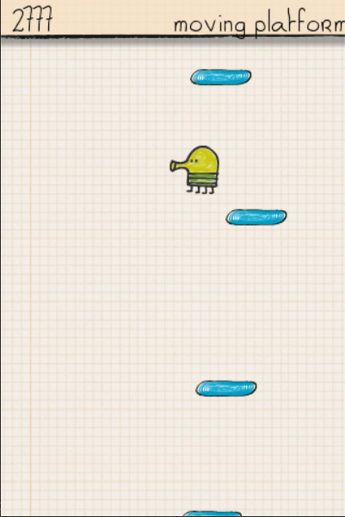

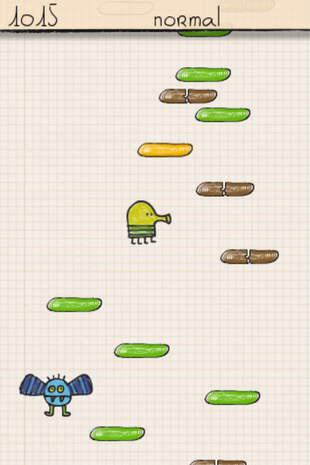

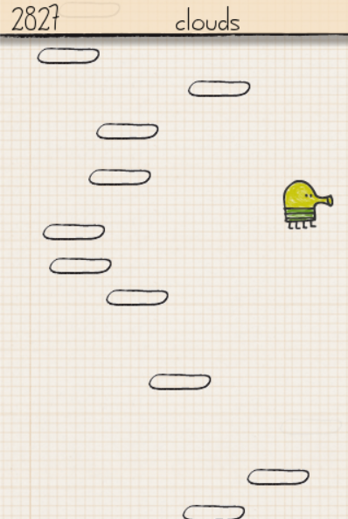

Used modules:

* pygame
* sys
* random
* os